**React Hands On 1 (Week 7)**

**Step 1:**

Open cmd and type

npm install –g create-react-app

**Step 2:**

Then type

Npx create-react-app cricketapp

**Step 3:**

Then navigate to that app and open it in vscode using

Code .

**Step 4:**

Create a new Folder in src called Components create ListOfPlayers.js that will be displayed when flag = true;

import React from 'react';

const players = [

  { name: 'Ram', score: 88 },

  { name: 'Rithick', score: 90 },

  { name: 'Kamal', score: 60 },

  { name: 'Anirutth', score: 43 },

  { name: 'Ravi', score: 76 },

  { name: 'Sunjay', score: 66 },

  { name: 'Nishan', score: 89 },

  { name: 'Surabh', score: 78 },

  { name: 'Karthick', score: 58 },

  { name: 'Surya', score: 82 },

  { name: 'Anil', score: 40 },

];

const ListOfPlayers = () => {

  const filteredPlayers = players.filter(p => p.score >= 70);

  return (

    <>

    <div>

        <h2>All Players</h2>

        <ul>

          {players.map((player, index) => (

            <li key={index}>{player.name}: {player.score}</li>

          ))}

        </ul>

      </div>

    <div>

      <h2>Players with Score less than 70</h2>

      <ul>

        {filteredPlayers.map((player, index) => (

          <li key={index}>{player.name} - {player.score}</li>

        ))}

      </ul>

    </div>

    </>

  );

};

export default ListOfPlayers;

**Step 5:**

Create another file called IndianPlayers which will display Odd players and Even players along with the merged players.

import React from 'react';

const IndianPlayers = () => {

  const team = ['Max', 'Carlos', 'Lewis', 'Oscar', 'Lando', 'Charles'];

  const [odd1, even1, odd2, even2, odd3, even3] = team;

  const T20players = ['Virat', 'Rohit', 'Surya'];

  const RanjiPlayers = ['Pujara', 'Rahane', 'Karun'];

  const mergedPlayers = [...T20players, ...RanjiPlayers];

  return (

    <div>

      <h2>Odd Team Players</h2>

      <ul>

        <li>{odd1}</li>

        <li>{odd2}</li>

        <li>{odd3}</li>

      </ul>

      <h2>Even Team Players</h2>

      <ul>

        <li>{even1}</li>

        <li>{even2}</li>

        <li>{even3}</li>

      </ul>

      <h2>Merged Team</h2>

      <ul>

        {mergedPlayers.map((p, i) => <li key={i}>{p}</li>)}

      </ul>

    </div>

  );

};

export default IndianPlayers;

**Step 6:**

Create app.js as follows that will decide the output:

**When flag = false;**

import React from 'react';

import ListOfPlayers from './Components/ListOfPlayers';

import IndianPlayers from './Components/IndianPlayers';

function App() {

  const flag = false;

  return (

    <div className="App">

      <h1>Cricket App</h1>

      {flag ? <ListOfPlayers /> : <IndianPlayers />}

    </div>

  );

}

export default App;

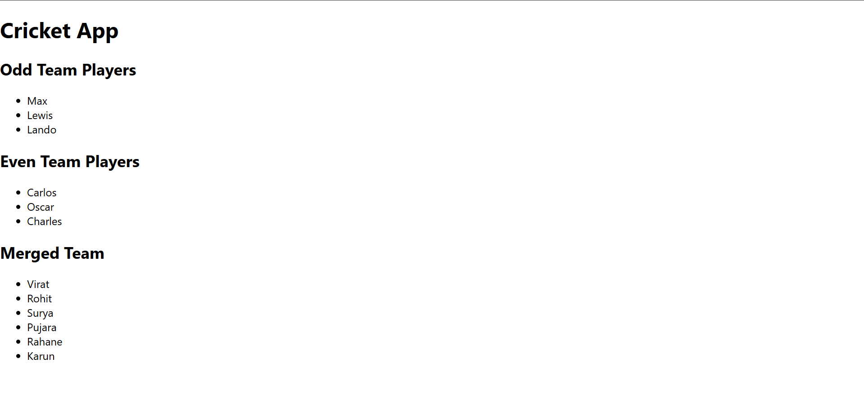

**When flag = true;**

